
Data Structures and
Algorithms (23CSE203)
LAB MANUAL
Submitted By:
Name | K MADHU SATYAKUMAR
Roll No | AV.SC.U4CSE25118
Year/Sem/Section | 2nd YEAR/SEM-3/CSE-B
Date of Submission
Submitted To:
Name | Dr. Raj Kumar Batchu
Department | CSE
Designation | Assistant Professor(Sl. Gr) , School of Computing

MARKS

S.No | TITLE | PAGE NO | REMARKS
1. | 1(A) Aim:  A rocket launch system displays countdown before launch . Using recursion write python program to display countdown to 1 followed by launch.  1(B) Aim:  Write a python program to calculate compound interest by taking user input.  1(C) Aim:  HR Department stores Employee Id’s in a list develop a recursive program in python to search for a given employee Id in the list.  1(D) Aim:  Develop a python program to print 1st n terms of Fibonacci series.  1(E) Aim:  Develop a python program to calculate factorial of a given number. | 2-10
2. | 2(A) Aim:  Write a python program to implement linear search.  2(B)(i) Aim: Write a python program to implement binary search with sorted array as input.  (ii) Aim: Write a python program to implement binary search with unsorted array as input. | 10-16
3. | 3(A) Aim:  Write a python program to apply insertion sort where input elements are taken from the user .  3(B) Aim:  Write a python program to apply bubble sort where input elements are taken from the user .  3(C) Aim:  Write a python program to apply selection sort where input elements are taken from the user . | 16-22
4. | 4(A) Aim:  Write a python program to apply Merge Sort where input elements are taken from the user .  4(B) Aim:  Write a python program to apply Quick Sort where input elements are taken from the user . | 23-28
5. | 5(A) Aim:  Write a python program to implement Singly Linked List and perform various operations (Creation, Insertion, Deletion, and Traversal).  5(B) Aim:  Write a python program to implement Circular Linked List and perform various operations (Insertion, Deletion, Traversal, and Display head/tail). | 28-36
6. | 6(A) Aim:  Write a python program to implement Stack operations (Push, Pop, Peek, Display) using an Array / List .  6(B) Aim:  Write a python program to implement Stack operations (Push, Pop, Peek, Display) using a Singly Linked List . | 36-42
7. | 7(A) Aim:  Write a python program to implement Linear Queue operations (Enqueue, Dequeue, Peek, Display) using an Array / List .  7(B) Aim:  Write a python program to implement Linear Queue operations (Enqueue, Dequeue, Peek, Display) using a Singly Linked List .  7(C) Aim:  Write a python program to implement Circular Queue operations (Enqueue, Dequeue, Peek, Display) using an Array / List . | 42-50
8. | 8(A) Aim:  Write a python program to implement Binary Tree representation and traversals (Preorder, Inorder, Postorder, Level-order) using an Array .  8(B) Aim:  Write a python program to implement Binary Tree representation and traversals (Preorder, Inorder, Postorder, Level-order) using a Linked List . | 50-56
9. | 9(A) Aim:  Write a python program to implement Binary Search Tree (BST) operations including Insertion, Search, Deletion, Finding Minimum/Maximum, Counting Nodes/Leaves/Internal Nodes, Calculating Height, and Tree Traversals (Inorder, Preorder, Postorder, Level Order) . | 56-64
LAB-1:
1.)Basic Programs Using Recursions :
A.) Aim: A rocket launch system displays countdown before launch . Using recursion write python program to display countdown to 1 followed by launch.
Program:
def rocket_countdown(n):
if n == 0:
print("LAUNCHED! ")
return

print(n)

rocket_countdown(n - 1)

start_num = int(input("Enter starting countdown number: "))

print("\n--- Starting Countdown ---")
rocket_countdown(start_num)

Output(+Ve Case):
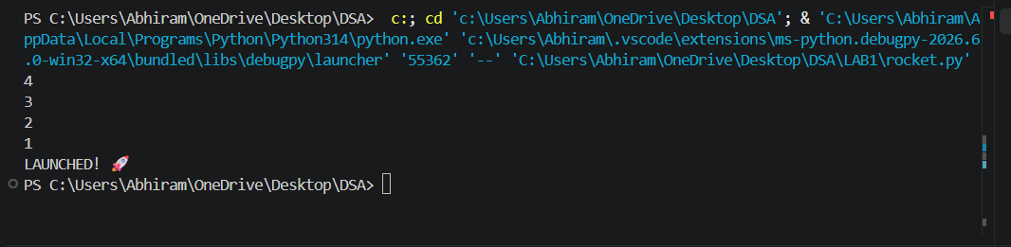
Output(-Ve Case):
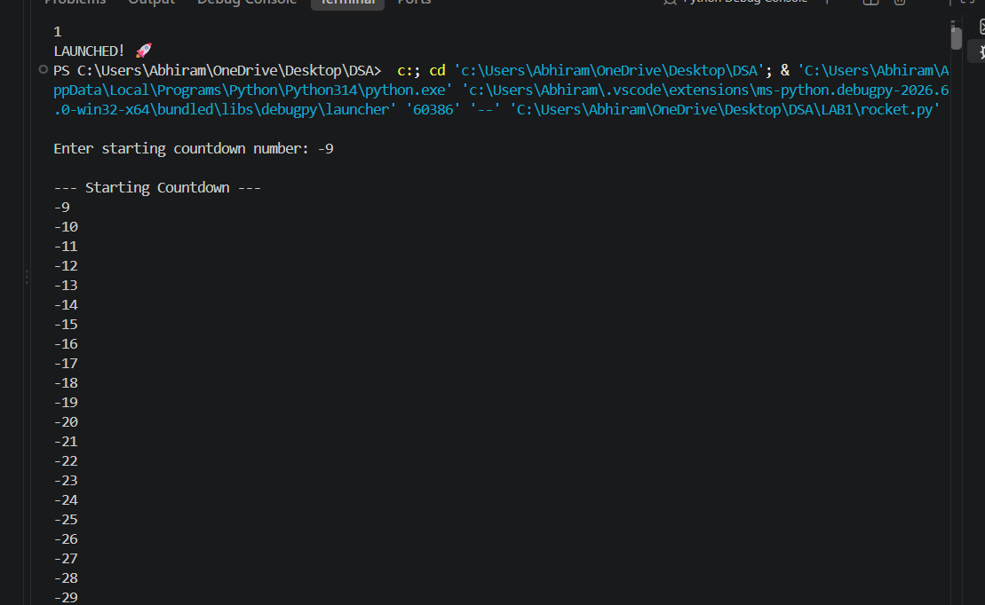
Explanation : This negative scenario has occurred due to infinite recursion . Countdown should never start from -ve integers as decrement will lead to negative infinity and the program crashes.

B.) Aim: Write a python program to calculate compound interest by taking user input.
Program:
def C_Int(p,n,r,t):
decimal_rate = r/100
total_amount = p*(1+decimal_rate/n)**(n*t)
interest_earned = total_amount - p
return total_amount, interest_earned

p = int(input("Enter the principal amount (₹) : "))
n = int(input("Times compounded per year : "))
r = float(input("Enter the annual interest rate (%) : "))
t = float(input("Enter the number of years : "))

final_balance, pure_interest = C_Int(p, n, r, t)

print("\n--- Financial Breakdown ---")
print(f"Interest Earned: ₹{pure_interest:.2f}")
print(f"Total Balance: ₹{final_balance:.2f}")

Output(+Ve Case):
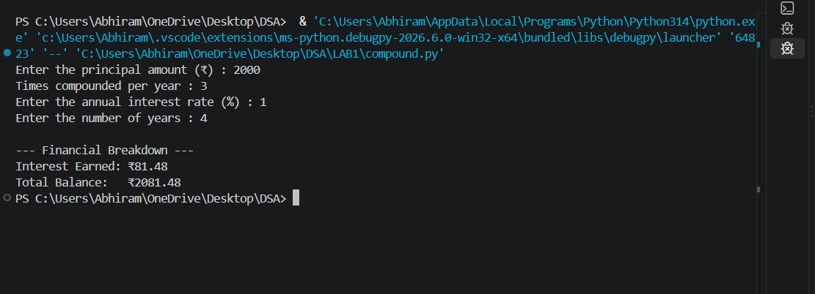
Output(-Ve Case):
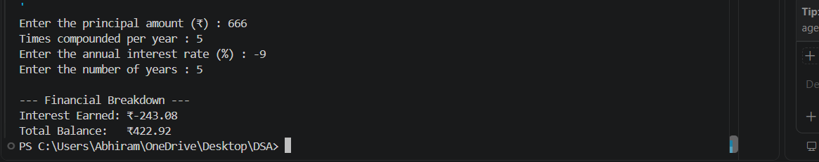
Explanation : Financial values such as Principal Amount, Rate of interest , Number of years should never be allowed to be negative this program projects a just output if and only if all of the input values are +ve.

C.) Aim: HR Department stores Employee Id’s in a list develop a recursive program in python to search for a given employee Id in the list.
Program:
def rec_bin_search(arr,key,low,high):
if low > high :
return -1
mid = (low+high)//2

if arr[mid] == key:
return mid
elif key < arr[mid]:
return rec_bin_search(arr,key,low,mid-1)
else:
return rec_bin_search(arr,key,mid+1,high)

Emp_Ids = [1002, 1005, 1012, 1025, 1040, 1077, 1100]
search_id = int(input("Enter Employee ID to search: "))

result_index = rec_bin_search(Emp_Ids,search_id,0,(len(Emp_Ids)-1))
if result_index != -1:
print(f"Employee ID {search_id} found at index {result_index}.")
else:
print(f"Employee ID {search_id} not found in the HR system.")

Output(+Ve Case):
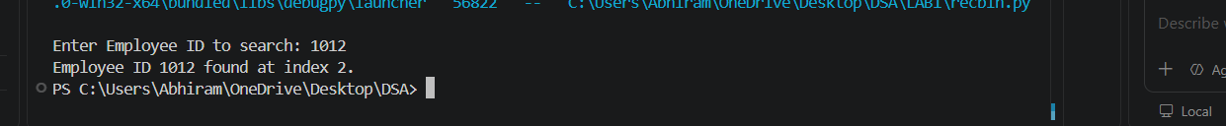
Output(-Ve Case):

Explanation : Binary Search only works when the given array is in sorted order. Although the element 1012 Exists in the lists the program has returned that it doesn’t which is an error.

D.) Aim: Develop a python program to print 1st n terms of Fibonacci series.
Program:
def fib(n):
if(n < 0):
print("Please enter a +ve number")
return None
if (n == 0 or n == 1):
return n
else:
return fib(n-1)+fib(n-2)

n = int(input("Enter the number : "))
for i in range (n+1):
print(f"{fib(i)}",end = " ")

Output(+Ve Case):
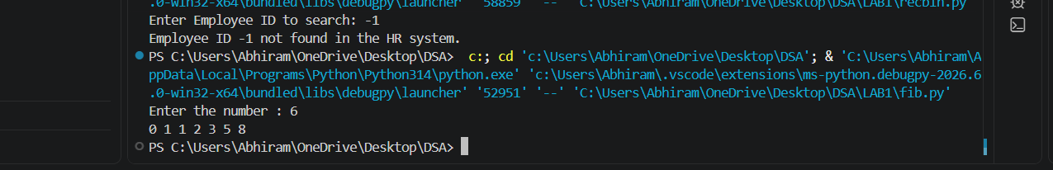
Output(-Ve Case):
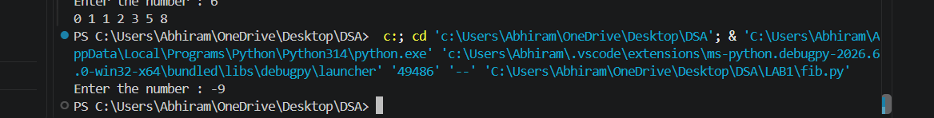
Explanation : a standard Fibonacci function should not accept negative numbers because negative inputs break the standard forward-sum logic and cause infinite loops.
E.) Aim: Develop a python program to calculate factorial of a given number.
Program:
def fac (n):
if n < 0 :
print("Please aenter a +ve number")
return None
if n == 0 or n == 1:
return 1
else:
return n*fac(n-1)

n = int(input("Enter a number : "))
print(f"The Factorial of {n} is {fac(n)}")

Output(+Ve Case):
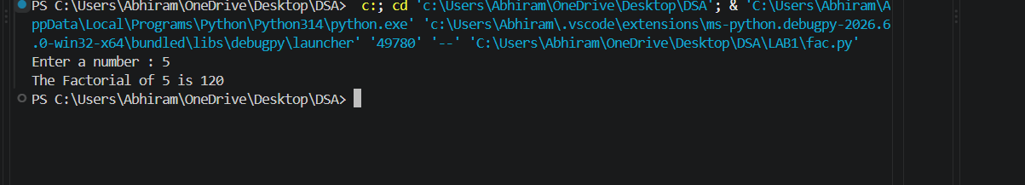
Output(-Ve Case):
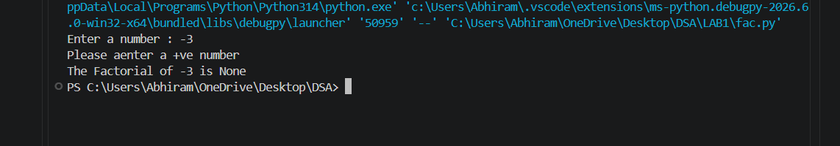
Explanation : The given Fibonacci sequence generator accepts only integer values giving values other than the integer data type such as float or special characters results in this type of Value Error.
LAB-2:
1.)Applying Searching Algorithms :
A.) Aim: Write a python program to implement linear search.
Program:
def lin_search(arr, key):
for i in range(len(arr)):
if arr[i] == key:
print(f"{key} at index {i}")
return
print(f"{key} not found")

n = int(input("Enter the number of elements: "))

arr = []

print("Enter elements:")
for i in range(n):
arr.append(int(input()))

key = int(input("Enter the key: "))

result = lin_search(arr, key)

Output(+Ve Case):
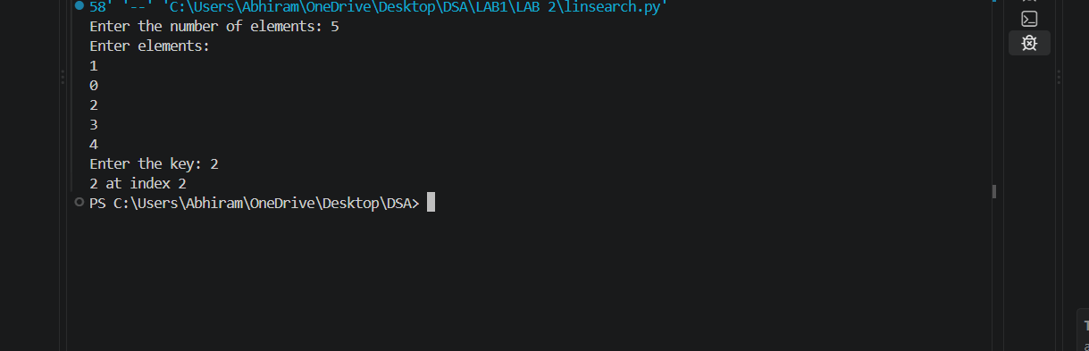
Output(-Ve Case):
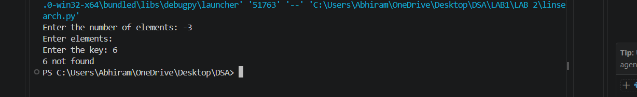
Explanation : The number of input elements should never be negative . In this case since input elements are -5 the program doesn’t allow me to enter any input elements nor is able to check the key given by the user.

B.)(i) Aim: Write a python program to implement binary search with sorted array as input.
Program:
def bin_search(arr,key):
low = 0
high = len(arr) - 1
while low <= high:
mid = (high+low)//2
if arr[mid] == key:
return mid
elif arr[mid] < key:
low = mid+1
else:
high = mid-1
return -1

n = int(input("Enter the number of elements: "))

arr = []

print("Enter elements:")
for i in range(n):
arr.append(int(input()))

key = int(input("Enter the key: "))

result = bin_search(arr, key)
if result!=-1:
print(f"Element found at index {result}")
else:
print("Element not found")
Output(+Ve Case):
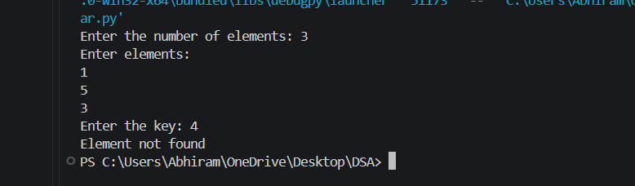
Output(-Ve Case):
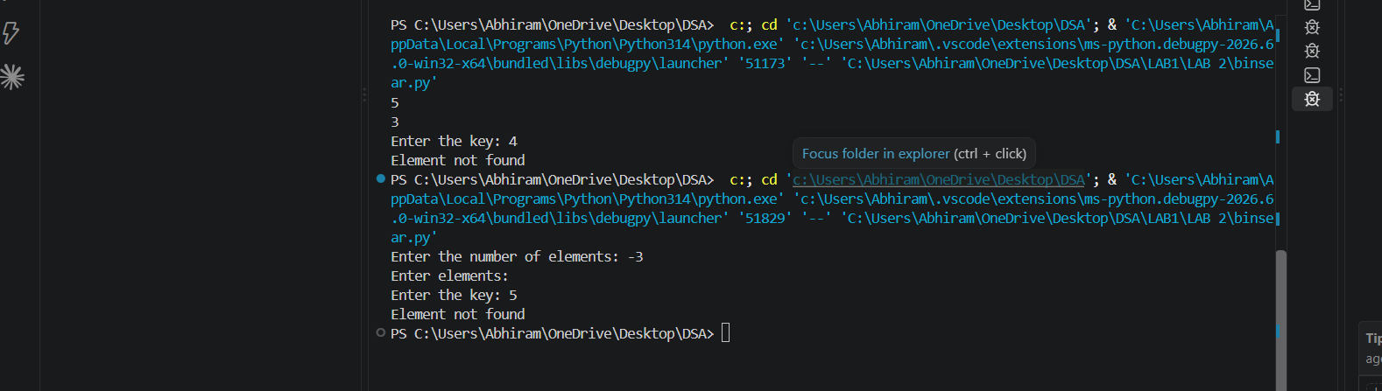
Explanation : The number of input elements should never be negative . In this case since input elements are -5 the program doesn’t allow me to enter any input elements nor is able to check the key given by the user.
(ii) Aim: Write a python program to implement binary search with unsorted array as input.
Program:
def bin_search(arr,key):
low = 0
high = len(arr) - 1
while low <= high:
mid = (high+low)//2
if arr[mid] == key:
return mid
elif arr[mid] < key:
low = mid+1
else:
high = mid-1
return -1

n = int(input("Enter the number of elements: "))

arr = []

print("Enter elements:")
for i in range(n):
arr.append(int(input()))
if arr == sorted(arr):
print("\n input list is already sorted")
else:
print("input list is not sorted")
print("sorting list....")
arr.sort()
print(f"Sorted List : {arr}")

key = int(input("Enter the key: "))

result = bin_search(arr, key)
if result!=-1:
print(f"Element found at index {result}")
else:
print("Element not found")

Output(+Ve Case):
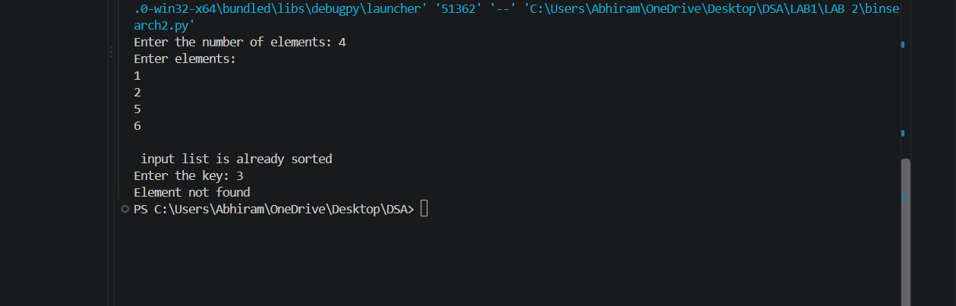

Output(-Ve Case):
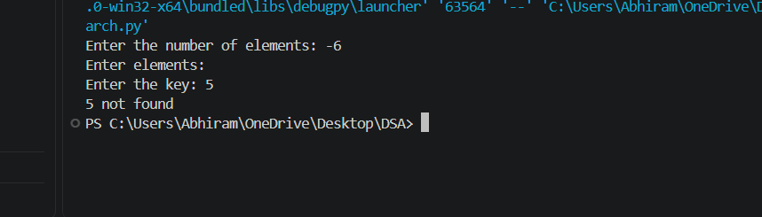

Explanation : The given Binary Search accepts only integer values giving values other than the integer data type such as float or special characters results in this type of Value Error.

LAB-3:
1.)Applying Sorting Algorithms :
A.) Aim: Write a python program to apply bubble sort where input elements are taken from the user .
Program:
def bubble_sort(arr):
n = len(arr)
for i in range(n-1):
for j in range(n-i-1):
if arr[j] > arr[j+1]:
arr[j],arr[j+1] = arr[j+1],arr[j]
return arr

n = int(input("Enter the number of elements: "))

arr = []

print("Enter elements:")
for i in range(n):
arr.append(int(input()))

result = bubble_sort(arr)
print(f"Sorted array : {result}")

Output(+Ve Case):
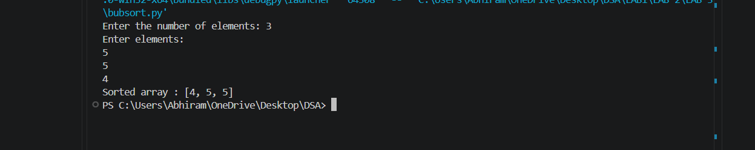
Output(-Ve Case):
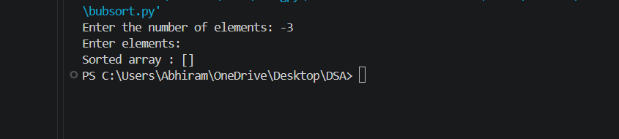
Explanation:
The input values for a given sorting algorithm for an array must never be null hence it throws the error invalid for int() input.
B.) Aim: Write a python program to apply insertion sort where input elements are taken from the user .
Program:
def insertion_sort(arr):
n = len(arr)
for i in range(1,n):
key = arr[i]
j = i-1
while j >= 0 and arr[j] > key:
arr[j+1] = arr[j]
j = j-1
arr[j+1] = key
return arr

n = int(input("Enter the number of elements: "))

arr = []

print("Enter elements:")
for i in range(n):
arr.append(int(input()))

result = insertion_sort(arr)
print(f"Sorted array : {result}")

Output(+Ve Case):
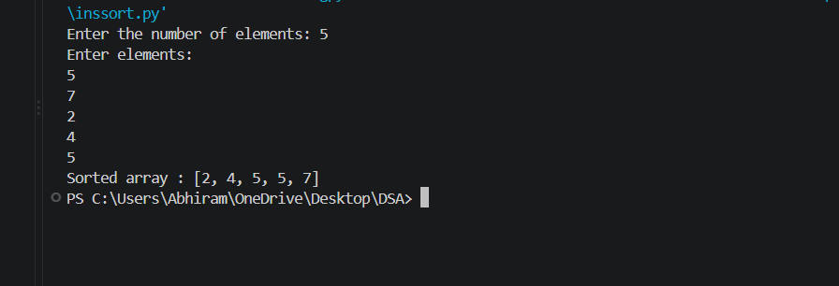
Output(-Ve Case):
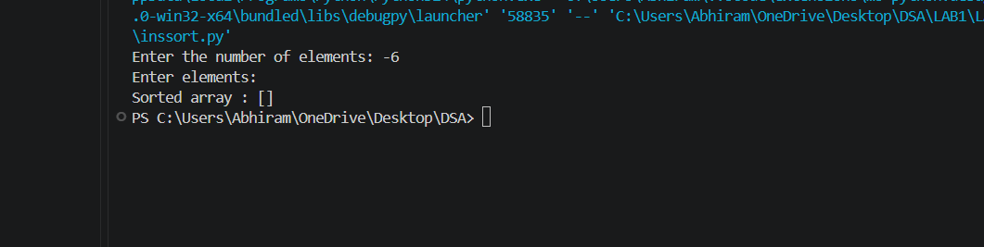
Explanation : The number of input elements should never be negative . In this case since input elements are -10 the program doesn’t allow me to enter any input elements nor is able to sort effeciently.

C.) Aim: Write a python program to apply selection sort where input elements are taken from the user .
Program:
def selection_sort(arr):
n = len(arr)
for i in range(n-1):
min_index = i
for j in range (i+1,n):
if arr[j] < arr[min_index]:
min_index = j
arr[i],arr[min_index] = arr[min_index],arr[i]
return arr

n = int(input("Enter the number of elements: "))

arr = []

print("Enter elements:")
for i in range(n):
arr.append(int(input()))

result = selection_sort(arr)
print(f"Sorted array : {result}")

Output(+Ve Case):
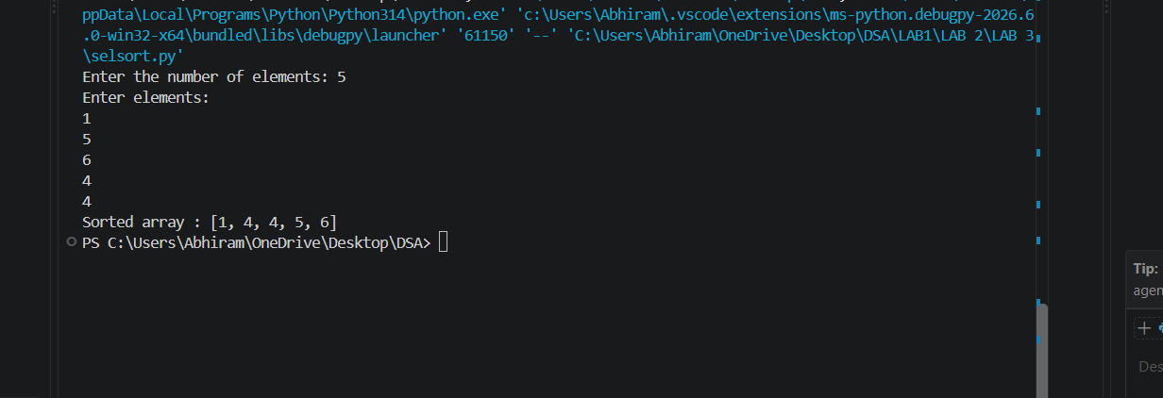

Output(-Ve Case):
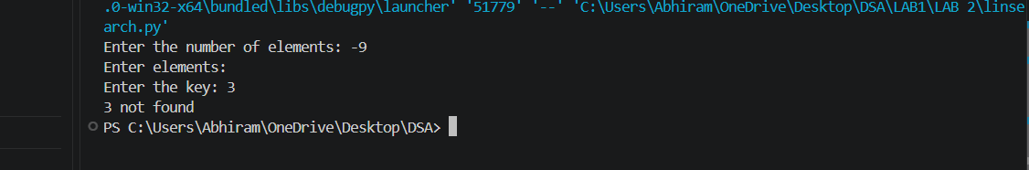
Explanation:
The given Selection Sort accepts only integer values giving values other than the integer data type such as float or special characters or strings results in this type of Value Error.

LAB-4:
1.)Applying Advanced Sorting Algorithms :
A.) Aim: Write a python program to apply Merge Sort where input elements are taken from the user .
Program:
def merge_sort(arr):
# Base Condition
if len(arr) <= 1:
return arr

# Divide Array
mid = len(arr) // 2
left = arr[:mid]
right = arr[mid:]

# Recursive calls
merge_sort(left)
merge_sort(right)

# Merge sorted halves
i = j = k = 0

while i < len(left) and j < len(right):
if left[i] <= right[j]:
arr[k] = left[i]
i += 1
else:
arr[k] = right[j]
j += 1
k += 1

# Copy remaining elements from Left Array
while i < len(left):
arr[k] = left[i]
i += 1
k += 1

# Copy remaining elements from Right Array
while j < len(right):
arr[k] = right[j]
j += 1
k += 1

return arr

n = int(input("Enter the number of elements: "))

arr = []

print("Enter elements:")
for i in range(n):
arr.append(int(input()))

print("Sorted Array :.......")
print(merge_sort(arr))

Output(+Ve Case):
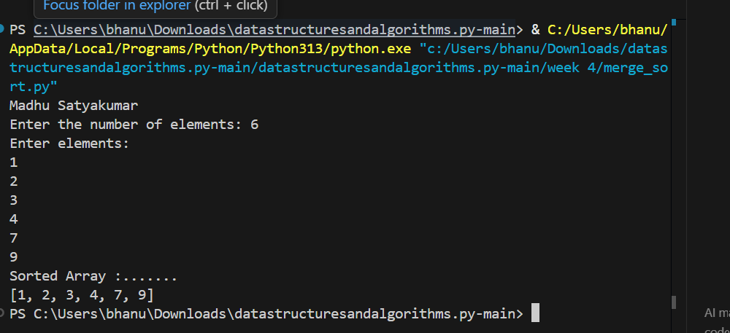

Explanation : In the positive scenario, Merge Sort follows the Divide and Conquer strategy, recursively splitting the list into single-element sub-arrays and merging them in sorted order with O(n log n) time complexity. In the negative scenario, entering a negative number of elements (such as -5) causes the input loop not to execute, producing an empty list [] without prompting for any elements. Furthermore, passing non-integer inputs (e.g., characters or floating-point values) triggers a ValueError during int() conversion.

B.) Aim: Write a python program to apply Quick Sort where input elements are taken from the user .
Program:
def quicksort(a,low,high):
if low < high:
i = low
j = high
pivot = low
while i < j:
while i < len(a) and a[i] <= a[pivot]:
i+=1
while a[j] > a[pivot]:
j-=1
if i < j:
a[i],a[j] = a[j],a[i]
a[j],a[pivot] = a[pivot],a[j]
quicksort(a,low,j-1)#Left Part
quicksort(a,j+1,high)#Right Part

#Entering the Elements
n = int(input("Enter the number of elements: "))
a = []

print("Enter elements:")
for i in range(n):
a.append(int(input()))

quicksort(a, 0, n - 1)

print("Sorted Array :.......")
print(a)

Output(+Ve Case):
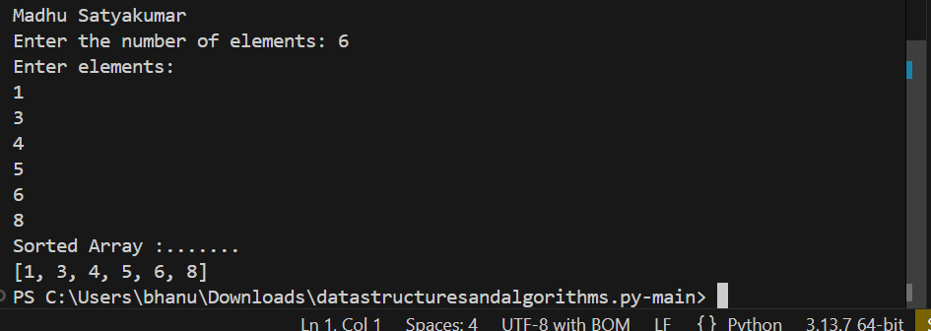

Explanation : In the positive scenario, Quick Sort selects a pivot element, partitions the array such that elements smaller than or equal to the pivot are on the left and larger elements are on the right, and recursively sorts the sub-arrays with an average time complexity of O(n log n). In the negative scenario, entering a negative number of elements yields an empty array where the recursive boundary condition (low < high) fails immediately, leaving an empty list without sorting. Additionally, non-integer inputs raise a ValueError.

LAB-5:
1.)Implementation of Linked Lists :
A.) Aim: Write a python program to implement Singly Linked List and perform various operations (Creation, Insertion at Beginning/End/Index, Deletion at Beginning/End/Value, Traversal, and Count) .
Program:
class Node:
def __init__(self, data):
self.data = data
self.next = None

class SinglyLinkedList:
def __init__(self):
self.head = None

def create(self):
n = int(input(("Enter number of elements:")))
for i in range(n):
x = int(input(("Enter value:")))
new = Node(x)
if self.head is None:
self.head = new
else:
temp = self.head
while temp.next:
temp = temp.next
temp.next = new

def insert_begin(self, data):
new = Node(data)
new.next = self.head
self.head = new

def insert_end(self, data):
new = Node(data)
if self.head is None:
self.head = new
else:
temp = self.head
while temp.next:
temp = temp.next
temp.next = new

def insert_index(self, index, data):
if index == 0:
self.insert_begin(data)
return
elif index > self.count() or index < 0:
print("Invalid Index")
return
new = Node(data)
temp = self.head
for i in range(index - 1):
temp = temp.next
new.next = temp.next
temp.next = new

def deleteAtBeg(self):
if self.head is None:
print("No Data to delete")
else:
temp = self.head
self.head = temp.next
print("Deleted Value = ",temp.data)

def deleteAtEnd(self):
if self.head is None:
print("No Data to delete")
elif self.head.next is None:
self.head = None
else:
temp = self.head
temp1 = temp
while temp.next:
temp1 = temp
temp = temp.next
temp1.next = None

def delete(self, value):
if self.head is None:
print("No Data to delete")
else:
temp = self.head
if temp and temp.data == value:
self.head = temp.next
print("Value deleted")
return
while temp.next and temp.next.data != value:
temp = temp.next

if temp.next is None:
print("Value not present")
else:
temp.next = temp.next.next
print("Value deleted")

def display(self):
if self.head is None:
print("No Data")
else:
temp = self.head
while temp:
print(temp.data, end=" -> ")
temp = temp.next
print("None")

def count(self):
if self.head is None:
print("No Linked List")
return 0
else:
c = 0
temp = self.head
while temp:
c += 1
temp = temp.next
print(f"Number of nodes = {c}")
return c

# Menu-driven implementation matching the provided snippet
if __name__ == "__main__":
sll = SinglyLinkedList()

while True:
print("\n1. Create\n2. Insert at Beginning\n3. Insert at End\n4. Insert at Index\n5. Delete Value\n6. Delete at Beginning\n7. Delete at End\n8. Count\n9. Display\n10. Exit")
ch = int(input("Enter choice: "))

if ch == 1:
sll.create()
elif ch == 2:
x = int(input("Value: "))
sll.insert_begin(x)
elif ch == 3:
x = int(input("Value: "))
sll.insert_end(x)
elif ch == 4:
idx = int(input("Index: "))
x = int(input("Value: "))
sll.insert_index(idx, x)
elif ch == 5:
x = int(input("Delete value: "))
sll.delete(x)
elif ch == 6:
sll.deleteAtBeg()
elif ch == 7:
sll.deleteAtEnd()
elif ch == 8:
sll.count()
elif ch == 9:
sll.display()
elif ch == 10:
break

Output(+Ve Case):
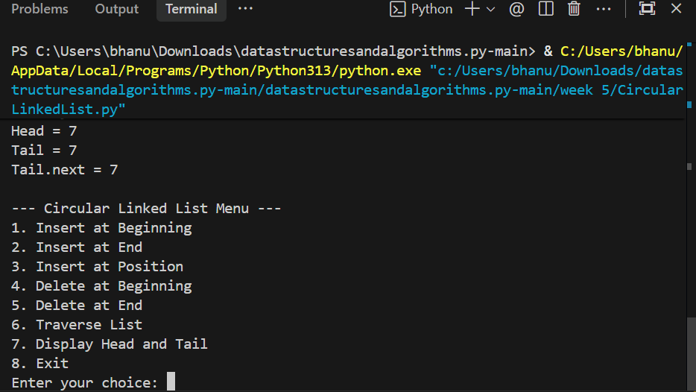

Explanation : In the positive scenario, elements are dynamically allocated into Node objects connected via next pointers, enabling efficient insertion at the beginning, end, and specific positions, as well as deletion and traversal with proper pointer reassignments. In the negative scenario, edge cases such as attempting to delete from an empty list output 'No Data to delete', deleting a non-existent value outputs 'Value not present', and inserting at a negative or out-of-bounds index outputs 'Invalid Index', preventing null-pointer reference errors.

B.) Aim: Write a python program to implement Circular Linked List and perform various operations (Insertion at Beginning/End/Position, Deletion at Beginning/End, Traversal, and Display Head/Tail) .
Program:
class Node:
def __init__(self, data):
self.data = data
self.next = None

class CircularLinkedList:
def __init__(self):
self.head = None
self.tail = None

# Insert at Beginning[cite: 13]
def insert_begin(self, data):
new = Node(data)
# Case 1: Empty list
if self.head is None:
self.head = new
self.tail = new
new.next = self.head
# Case 2: Non-empty list
else:
new.next = self.head
self.head = new
self.tail.next = self.head

# Insert at End[cite: 14]
def insert_end(self, data):
new = Node(data)
# Case 1: Empty list
if self.head is None:
self.head = new
self.tail = new
new.next = self.head
# Case 2: Non-empty list
else:
new.next = self.head
self.tail.next = new
self.tail = new

# Insert at Particular Position[cite: 15]
# Position starts from 0
def insert_position(self, position, data):
# Insert at beginning
if position == 0:
self.insert_begin(data)
return

if self.head is None or position < 0:
print("Invalid position")
return

new = Node(data)
temp = self.head

# Move to the node before the required position[cite: 16]
for i in range(position - 1):
temp = temp.next
# We have completed one circle
if temp == self.head:
print("Invalid position")
return

# Insert new node
new.next = temp.next
temp.next = new

# If inserted after tail, update tail
if temp == self.tail:
self.tail = new

# Delete at Beginning[cite: 17]
def delete_begin(self):
if self.head is None:
print("List is empty")
return

# Only one node
if self.head == self.tail:
self.head = None
self.tail = None
# More than one node
else:
self.head = self.head.next
self.tail.next = self.head

# Delete at End[cite: 18]
def delete_end(self):
if self.head is None:
print("List is empty")
return

# Only one node
if self.head == self.tail:
self.head = None
self.tail = None
return

# Find node before tail
temp = self.head
while temp.next != self.tail:
temp = temp.next
temp.next = self.head
self.tail = temp

# Traverse the Circular Linked List[cite: 19]
def traverse(self):
if self.head is None:
print("List is empty")
return

temp = self.head
while True:
print(temp.data, end=" -> ")
temp = temp.next
if temp == self.head:
break
print("(back to head)")

# Display Head and Tail[cite: 20]
def display_head_tail(self):
if self.head is None:
print("List is empty")
else:
print("Head =", self.head.data)
print("Tail =", self.tail.data)
print("Tail.next =", self.tail.next.data)

# Menu-driven implementation
if __name__ == "__main__":
cll = CircularLinkedList()

while True:
print("\n--- Circular Linked List Menu ---")
print("1. Insert at Beginning")
print("2. Insert at End")
print("3. Insert at Position")
print("4. Delete at Beginning")
print("5. Delete at End")
print("6. Traverse List")
print("7. Display Head and Tail")
print("8. Exit")

ch = int(input("Enter your choice: "))

if ch == 1:
x = int(input("Value: "))
cll.insert_begin(x)
elif ch == 2:
x = int(input("Value: "))
cll.insert_end(x)
elif ch == 3:
pos = int(input("Position (starts from 0): "))
x = int(input("Value: "))
cll.insert_position(pos, x)
elif ch == 4:
cll.delete_begin()
elif ch == 5:
cll.delete_end()
elif ch == 6:
cll.traverse()
elif ch == 7:
cll.display_head_tail()
elif ch == 8:
print("Exiting...")
break
else:
print("Invalid choice, please try again.")

Output(+Ve Case):
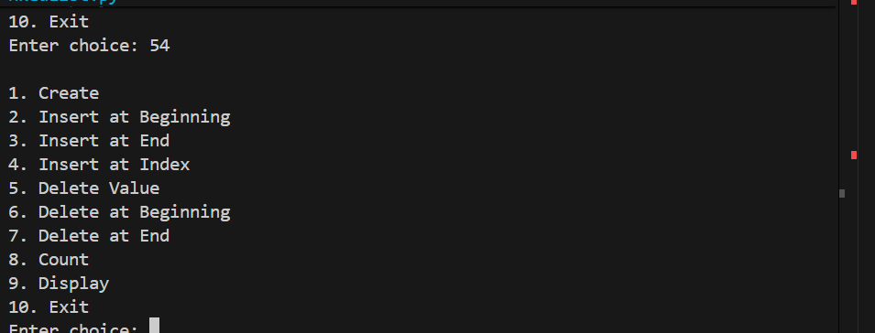
Explanation : In the positive scenario, the circular linked list connects the last node (tail) back to the first node (head), maintaining circular continuity and allowing constant-time insertions at both ends. Traversing the list loops through each element and stops when temp returns to head. In the negative scenario, deleting or displaying on an empty list outputs 'List is empty', and supplying negative or invalid insertion positions outputs 'Invalid position', preventing infinite loops and null pointer exceptions.

LAB-6:
1.)Implementation of Stacks :
A.) Aim: Write a python program to implement Stack operations (Push, Pop, Peek, Display) using an Array / List .
Program:
class StackEx:
#
def __init__(self, size):
self.size = size
self.stack = [None] * size
self.top = -1

# Push operation
def push(self, item):
if self.top == self.size - 1:
print("Stack Overflow")
else:
self.top += 1
self.stack[self.top] = item
print(item, "pushed into the stack")

# Pop operation
def pop(self):
if self.top == -1:
print("Stack Underflow")
else:
item = self.stack[self.top]
self.stack[self.top] = None
self.top -= 1
print(item, "popped from the stack")

# Peek operation
def peek(self):
if self.top == -1:
print("Stack is empty")
else:
print("Top element:", self.stack[self.top])

# Display operation
def display(self):
if self.top == -1:
print("Stack is empty")
else:
print("The elements of the stack are:")
for i in range(self.top, -1, -1):
print(self.stack[i])

# Create stack
size = int(input("Enter the size of the stack: "))
s = StackEx(size)
while True:
print("\n----- STACK MENU -----")
print("1. Push")
print("2. Pop")
print("3. Peek")
print("4. Display")
print("5. Exit")
choice = int(input("Enter your choice: "))
if choice == 1:
item = int(input("Enter the element to push: "))
s.push(item)
elif choice == 2:
s.pop()
elif choice == 3:
s.peek()
elif choice == 4:
s.display()
elif choice == 5:
print("Program terminated.")
break
else:
print("Invalid choice")

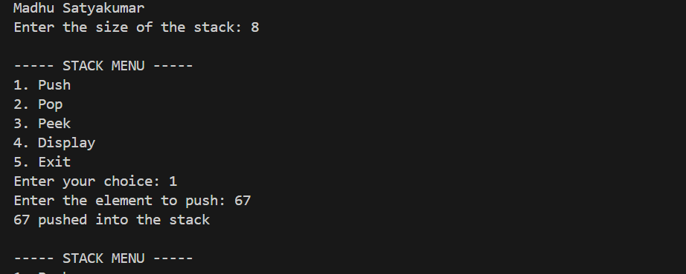
Output(+Ve Case):

Output(-Ve Case):

Explanation : In the positive scenario, the array-based Stack enforces the LIFO (Last-In, First-Out) principle, allowing push, pop, and peek operations in O(1) time complexity while tracking the top index. In the negative scenario, attempting to push an element into a full stack (top == size - 1) triggers 'Stack Overflow', and attempting to pop or peek from an empty stack (top == -1) triggers 'Stack Underflow' or 'Stack is empty', guarding against array index errors.

B.) Aim: Write a python program to implement Stack operations (Push, Pop, Peek, Display) using a Singly Linked List .
Program:
class Node:
#
def __init__(self, data):
self.data = data
self.next = None

class Stack:
def __init__(self):
self.top = None

# Push operation[cite: 26, 27]
def push(self, data):
new = Node(data)
new.next = self.top
self.top = new
print(data, "pushed into stack")

# Pop operation
def pop(self):
if self.top is None:
print("Stack Underflow")
else:
temp = self.top
print(temp.data, "popped from stack")
self.top = self.top.next

# Peek operation
def peek(self):
if self.top is None:
print("Stack is empty")
else:
print("Top element:", self.top.data)

# Display operation
def display(self):
if self.top is None:
print("Stack is empty")
else:
temp = self.top
print("Stack elements:")
while temp is not None:
print(temp.data)
temp = temp.next

#
if __name__ == "__main__":
s = Stack()
while True:
print("\n--- STACK USING LINKED LIST ---")
print("1. Push")
print("2. Pop")
print("3. Peek")
print("4. Display")
print("5. Exit")
choice = int(input("Enter your choice: "))
if choice == 1:
data = int(input("Enter the element: "))
s.push(data)
elif choice == 2:
s.pop()
elif choice == 3:
s.peek()
elif choice == 4:
s.display()
elif choice == 5:
print("Program terminated")
break
else:
print("Invalid choice")

Output(+Ve Case):
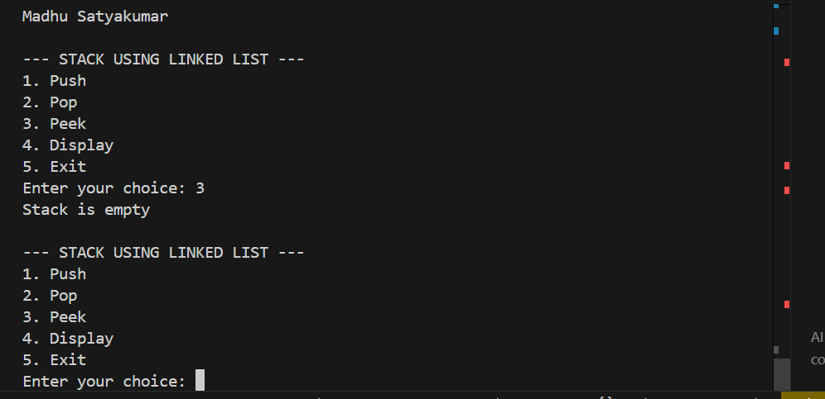
Explanation : In the positive scenario, dynamic node allocation allows the stack to grow dynamically without fixed capacity limitations, executing push and pop operations at the top node in O(1) time. In the negative scenario, calling pop or peek when the stack is empty (self.top is None) prints 'Stack Underflow' or 'Stack is empty', preventing dereferencing a None object.

LAB-7:
1.)Implementation of Queues :
A.) Aim: Write a python program to implement Linear Queue operations (Enqueue, Dequeue, Peek, Display) using an Array / List .
Program:
class Queue:
def __init__(self,size):
self.size = size
self.queue = [None]*size
self.front = -1
self.rear = -1
#Enqueue Operation
def enqueue(self,x):
if self.rear == self.size -1:
print("Queue Overflow")
else:
if self.front == -1:
self.front = 0
self.rear+=1
self.queue[self.rear] = x
print(f"{x} inserted in the queue")
#Dequeue Operation
def dequeue(self):
if self.front == -1 or self.front > self.rear:
print("Queue Underflow")
else:
x = self.queue[self.front]
self.queue[self.front] = None
self.front+=1
print(f"{x} deleted from the queue")

if self.front > self.rear:
self.front = -1
self.rear = -1
#Peek Operation
def peek(self):
if self.front == -1:
print("Queue is Empty")
else:
print("Front Element:",self.queue[self.front])
#Display Operation
def display(self):
if self.front == -1:
print("Queue is Empty")
else:
print("The Elements of the Queue are:")
for i in range (self.front,self.rear+1):
print(self.queue[i])

size = int(input("Enter the maximum size of the queue: "))
q = Queue(size)
while True:
print("\n----- QUEUE MENU -----")
print("1. Enqueue")
print("2. Dequeue")
print("3. Peek")
print("4. Display")
print("5. Exit")
choice = int(input("Enter your choice: "))
if choice == 1:
item = int(input("Enter the element to enqueue: "))
q.enqueue(item)
elif choice == 2:
q.dequeue()
elif choice == 3:
q.peek()
elif choice == 4:
q.display()
elif choice == 5:
print("Program terminated.")
break
else:
print("Invalid choice")

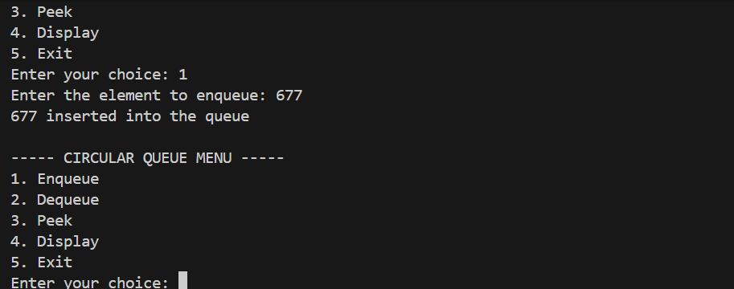
Output(+Ve Case):

Explanation : In the positive scenario, elements are enqueued at the rear and dequeued from the front following the FIFO (First-In, First-Out) principle in O(1) time. In the negative scenario, Queue Overflow occurs when rear reaches size - 1 (even if front spaces were vacated by earlier dequeue operations, illustrating linear queue memory limitations), while Queue Underflow is reported when dequeue is called on an empty queue (front == -1 or front > rear).

B.) Aim: Write a python program to implement Linear Queue operations (Enqueue, Dequeue, Peek, Display) using a Singly Linked List .
Program:
# Node structure
class Node:
def __init__(self, data):
self.data = data
self.next = None

class QueueEx:
def __init__(self):
self.front = None
self.rear = None

# Enqueue operation
def enqueue(self, x):
new = Node(x)
if self.rear is None:
self.front = self.rear = new
else:
self.rear.next = new
self.rear = new
# FIXED: Changed 'item' to 'x' so it correctly prints the inserted value
print(x, "inserted into the queue")

# Dequeue operation
def dequeue(self):
if self.front is None:
print("Queue Underflow")
else:
x = self.front.data
self.front = self.front.next
if self.front is None:
self.rear = None
print(f"{x} deleted from the queue")

# Peek operation
def peek(self):
if self.front is None:
print("Queue is empty")
else:
print("Front element:", self.front.data)

# Display operation
def display(self):
if self.front is None:
print("Queue is empty")
else:
print("The elements of the queue are:")

temp = self.front
while temp is not None:
print(temp.data)
temp = temp.next

q = QueueEx()

while True:
print("\n----- QUEUE MENU -----")
print("1. Enqueue")
print("2. Dequeue")
print("3. Peek")
print("4. Display")
print("5. Exit")
choice = int(input("Enter your choice: "))
if choice == 1:
item = int(input("Enter the element to enqueue: "))
q.enqueue(item)
elif choice == 2:
q.dequeue()
elif choice == 3:
q.peek()
elif choice == 4:
q.display()
elif choice == 5:
print("Program terminated.")
break
else:
print("Invalid choice")

Output(+Ve Case):
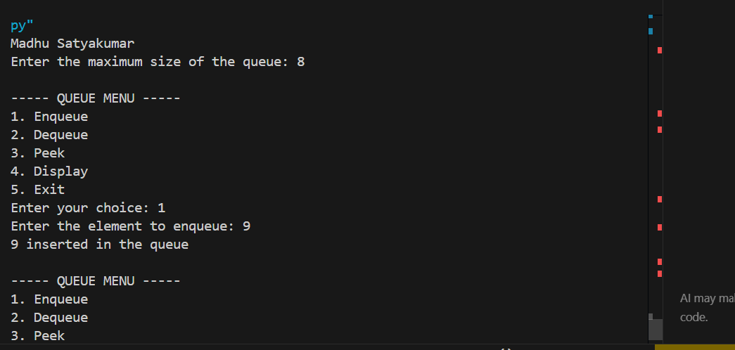

Explanation : In the positive scenario, dynamic node allocation eliminates the fixed size limit of array queues, providing O(1) enqueue at the rear and O(1) dequeue at the front. In the negative scenario, invoking dequeue, peek, or display on an empty queue (front is None) triggers the Queue Underflow guard, safeguarding against null pointer errors.

C.) Aim: Write a python program to implement Circular Queue operations (Enqueue, Dequeue, Peek, Display) using an Array / List .
Program:
class CircularQueue:
def __init__(self, size):
self.size = size
self.queue = [None] * size
self.front = -1
self.rear = -1

def enqueue(self, item):
if (self.rear + 1) % self.size == self.front:
print("Queue Overflow")
elif self.front == -1:
self.front = 0
self.rear = 0
self.queue[self.rear] = item
print(item, "inserted into the queue")
else:
self.rear = (self.rear + 1) % self.size
self.queue[self.rear] = item
print(item, "inserted into the queue")

def dequeue(self):
if self.front == -1:
print("Queue Underflow")
# Only one element is present
elif self.front == self.rear:
item = self.queue[self.front]
self.queue[self.front] = None
self.front = -1
self.rear = -1
print(item, "deleted from the queue")
# More than one element
else:
item = self.queue[self.front]
self.queue[self.front] = None
self.front = (self.front + 1) % self.size
print(item, "deleted from the queue")

# Peek operation
def peek(self):
if self.front == -1:
print("Queue is empty")
else:
print("Front element:", self.queue[self.front])

# Display operation
def display(self):
if self.front == -1:
print("Queue is empty")
else:
print("The elements of the queue are:")
i = self.front
while True:
print(self.queue[i])
if i == self.rear:
break
i = (i + 1) % self.size

# Create Circular Queue
size = int(input("Enter the size of the queue: "))
q = CircularQueue(size)

while True:
print("\n----- CIRCULAR QUEUE MENU -----")
print("1. Enqueue")
print("2. Dequeue")
print("3. Peek")
print("4. Display")
print("5. Exit")
choice = int(input("Enter your choice: "))
if choice == 1:
item = int(input("Enter the element to enqueue: "))
q.enqueue(item)
elif choice == 2:
q.dequeue()
elif choice == 3:
q.peek()
elif choice == 4:
q.display()
elif choice == 5:
print("Program terminated.")
break
else:
print("Invalid choice")

Output(+Ve Case):
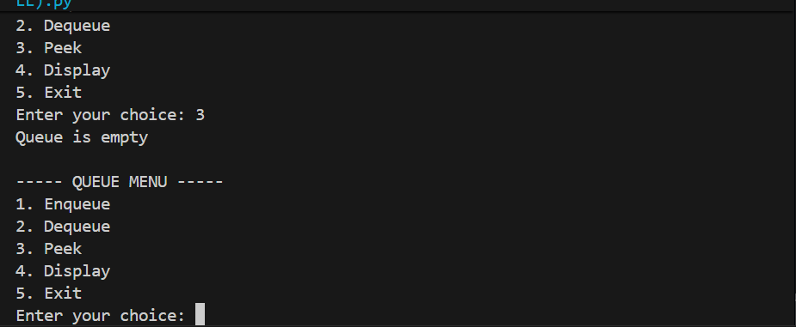
Explanation : In the positive scenario, the circular queue uses modulo arithmetic ((rear + 1) % size and (front + 1) % size) to wrap around indices, efficiently recycling memory slots freed by prior dequeue operations. In the negative scenario, Queue Overflow is detected when (rear + 1) % size == front, preventing unread data from being overwritten, and Queue Underflow is caught when front == -1 on an empty queue.

LAB-8:
1.)Implementation of Binary Trees :
A.) Aim: Write a python program to implement Binary Tree representation and traversals (Preorder, Inorder, Postorder, Level-order) using an Array .
Program:
class BinaryTreeArray:
def __init__(self, size):
self.tree = [None] * size
self.size = size

def set_root(self, data):
self.tree[0] = data

def set_left(self, parent_index, data):
child_index = 2 * parent_index + 1

if child_index < self.size:
self.tree[child_index] = data
else:
print("Index out of range!")

def set_right(self, parent_index, data):
child_index = 2 * parent_index + 2

if child_index < self.size:
self.tree[child_index] = data
else:
print("Index out of range!")

def preorder(self, index=0):
if index >= self.size or self.tree[index] is None:
return

print(self.tree[index], end=" ")
self.preorder(2 * index + 1)
self.preorder(2 * index + 2)

def inorder(self, index=0):
if index >= self.size or self.tree[index] is None:
return

self.inorder(2 * index + 1)
print(self.tree[index], end=" ")
self.inorder(2 * index + 2)

def postorder(self, index=0):
if index >= self.size or self.tree[index] is None:
return

self.postorder(2 * index + 1)
self.postorder(2 * index + 2)
print(self.tree[index], end=" ")

def level_order(self):
for value in self.tree:
if value is not None:
print(value, end=" ")

def display(self):
print("\nArray Representation:")

for i in range(self.size):
print(f"Index {i}: {self.tree[i]}")

tree = BinaryTreeArray(7)

tree.set_root('A')
tree.set_left(0, 'B')
tree.set_right(0, 'C')
tree.set_left(1, 'D')
tree.set_right(1, 'E')
tree.set_right(2, 'F')

tree.display()

print("\nPreorder: ", end="")
tree.preorder()

print("\nInorder: ", end="")
tree.inorder()

print("\nPostorder: ", end="")
tree.postorder()

print("\nLevel-order: ", end="")
tree.level_order()

Output(+Ve Case):
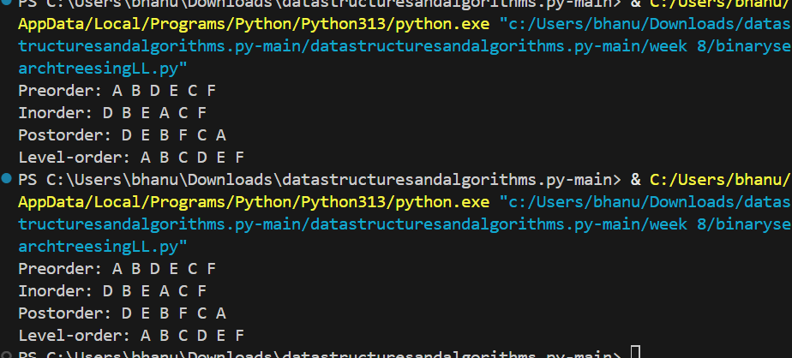

Explanation : In the positive scenario, the binary tree is sequentially mapped into an array where left child is at 2*i + 1 and right child is at 2*i + 2, and depth-first (preorder, inorder, postorder) and breadth-first (level-order) traversals visit all stored nodes correctly. In the negative scenario, attempting to insert a child node beyond the allocated array capacity (child_index >= size) prints 'Index out of range!', preventing Python IndexError exceptions.

B.) Aim: Write a python program to implement Binary Tree representation and traversals (Preorder, Inorder, Postorder, Level-order) using a Linked List .
Program:
class Node:
def __init__(self, data):
self.data = data
self.left = None
self.right = None

class BinaryTree:
def __init__(self):
self.root = None

def create_tree(self):
self.root = Node('A')
self.root.left = Node('B')
self.root.right = Node('C')
self.root.left.left = Node('D')
self.root.left.right = Node('E')
self.root.right.right = Node('F')

def preorder(self, node):
if node is None:
return
print(node.data, end=" ")
self.preorder(node.left)
self.preorder(node.right)

def inorder(self, node):
if node is None:
return
self.inorder(node.left)
print(node.data, end=" ")
self.inorder(node.right)

def postorder(self, node):
if node is None:
return
self.postorder(node.left)
self.postorder(node.right)
print(node.data, end=" ")

def level_order(self):
if self.root is None:
return

queue = [self.root]

while queue:
node = queue.pop(0)
print(node.data, end=" ")

if node.left is not None:
queue.append(node.left)

if node.right is not None:
queue.append(node.right)

tree = BinaryTree()
tree.create_tree()

print("Preorder: ", end="")
tree.preorder(tree.root)

print("\nInorder: ", end="")
tree.inorder(tree.root)

print("\nPostorder: ", end="")
tree.postorder(tree.root)

print("\nLevel-order: ", end="")
tree.level_order()

Output(+Ve Case):
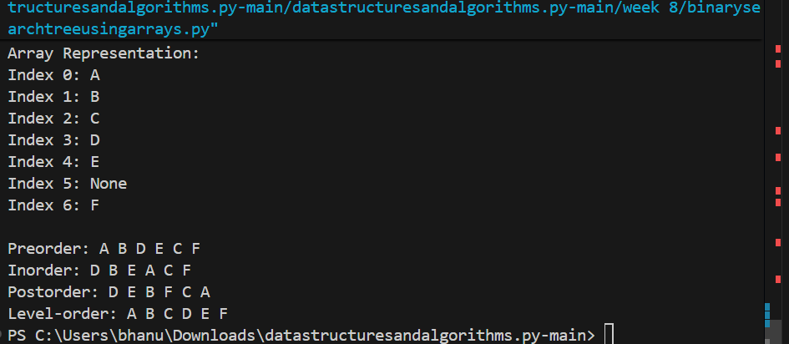
Explanation : In the positive scenario, linked nodes dynamically connect hierarchical parent-child relationships through left and right pointers without size constraints, enabling clean recursive traversals and queue-based level order traversal. In the negative scenario, base termination conditions (if node is None: return) ensure that leaf children or empty trees terminate safely without raising an AttributeError.

LAB-9:
1.)Binary Search Tree Operations and Traversals :
A.) Aim: Write a python program to implement Binary Search Tree (BST) operations including Insertion, Search, Deletion, Finding Minimum/Maximum, Counting Nodes/Leaves/Internal Nodes, Calculating Height, and Tree Traversals (Inorder, Preorder, Postorder, Level Order) .
Program:
class Node:
def __init__(self, data):
self.data = data
self.left = None
self.right = None

def insert(root, x):
if root is None:
return Node(x)
if x < root.data:
root.left = insert(root.left, x)
elif x > root.data:
root.right = insert(root.right, x)
else:
print("Duplicate value is not allowed.")
return root

def inorder(root):
if root is None:
return
inorder(root.left)
print(root.data, end=" ")
inorder(root.right)

def preorder(root):
if root is None:
return
print(root.data, end=" ")
preorder(root.left)
preorder(root.right)

def postorder(root):
if root is None:
return
postorder(root.left)
postorder(root.right)
print(root.data, end=" ")

def find_min(root):
if root is None:
return None
while root.left is not None:
root = root.left
return root

def find_max(root):
if root is None:
return None
while root.right is not None:
root = root.right
return root

def search(root, data):
if root is None:
return None
if data < root.data:
return search(root.left, data)
elif data > root.data:
return search(root.right, data)
else:
return root

def count_nodes(root):
if root is None:
return 0
return count_nodes(root.left) + count_nodes(root.right) + 1

def count_leaves(root):
if root is None:
return 0
if root.left is None and root.right is None:
return 1
return count_leaves(root.left) + count_leaves(root.right)

def count_internal(root):
if root is None:
return 0
if root.left is None and root.right is None:
return 0
return count_internal(root.left) + count_internal(root.right) + 1

def height(root):
if root is None:
return -1
left_height = height(root.left)
right_height = height(root.right)
return max(left_height, right_height) + 1

def delete(root, x):
if root is None:
print("Element not found.")
return None
if x < root.data:
root.left = delete(root.left, x)
elif x > root.data:
root.right = delete(root.right, x)
else:
# Case 1: Node has no children
if root.left is None and root.right is None:
root = None
# Case 2: Node has only right child
elif root.left is None:
root = root.right
# Case 3: Node has only left child
elif root.right is None:
root = root.left
# Case 4: Node has two children
else:
successor = find_min(root.right)
root.data = successor.data
root.right = delete(root.right, successor.data)
return root

def print_level(root, level):
if root is None:
return
if level == 0:
print(root.data, end=" ")
else:
print_level(root.left, level - 1)
print_level(root.right, level - 1)

def level_order(root):
h = height(root)
for level in range(h):
print_level(root, level)

root = None
while True:
print("\n\n******** BINARY SEARCH TREE ********")
print("1. INSERT")
print("2. PREORDER TRAVERSAL")
print("3. INORDER TRAVERSAL")
print("4. POSTORDER TRAVERSAL")
print("5. FIND MINIMUM")
print("6. FIND MAXIMUM")
print("7. SEARCH")
print("8. DELETE")
print("9. COUNT NODES")
print("10. COUNT LEAVES")
print("11. COUNT INTERNAL NODES")
print("12. HEIGHT")
print("13. LEVEL ORDER TRAVERSAL")
print("14. EXIT")

choice = int(input("Enter your choice: "))
if choice == 1:
data = int(input("Enter the data to be inserted: "))
root = insert(root, data)
print("Element inserted successfully.")
elif choice == 2:
print("Preorder Traversal:", end=" ")
if root is None:
print("Tree is empty.")
else:
preorder(root)
print()
elif choice == 3:
print("Inorder Traversal:", end=" ")
if root is None:
print("Tree is empty.")
else:
inorder(root)
print()
elif choice == 4:
print("Postorder Traversal:", end=" ")
if root is None:
print("Tree is empty.")
else:
postorder(root)
print()
elif choice == 5:
node = find_min(root)
if node is None:
print("Tree is empty.")
else:
print("Minimum element:", node.data)
elif choice == 6:
node = find_max(root)
if node is None:
print("Tree is empty.")
else:
print("Maximum element:", node.data)
elif choice == 7:
data = int(input("Enter the data to be searched: "))
node = search(root, data)
if node is None:
print("Element", data, "is not found.")
else:
print("Element", data, "is found.")
elif choice == 8:
data = int(input("Enter the data to be deleted: "))
root = delete(root, data)
elif choice == 9:
print("Number of nodes:", count_nodes(root))
elif choice == 10:
print("Number of leaf nodes:", count_leaves(root))
elif choice == 11:
print("Number of internal nodes:", count_internal(root))
elif choice == 12:
print("Height of BST:", height(root))
elif choice == 13:
print("Level Order Traversal:", end=" ")
if root is None:
print("Tree is empty.")
else:
level_order(root)
print()
elif choice == 14:
print("Program terminated.")
break
else:
print("Invalid choice. Please try again.")

Output(+Ve Case):
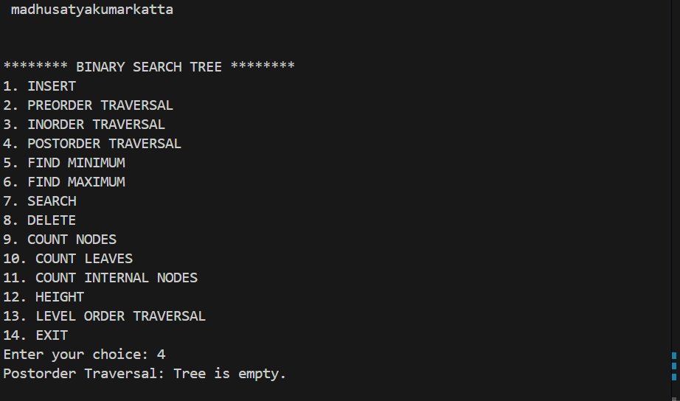

Explanation : In the positive scenario, the Binary Search Tree satisfies the BST invariant (left subtree values < root value < right subtree values), providing logarithmic search, insertion, and deletion on average. The Inorder traversal naturally prints all tree elements in sorted ascending order. In the negative scenario, attempting to insert duplicate keys prints 'Duplicate value is not allowed.', searching for or deleting an absent element outputs 'Element <x> is not found' or 'Element not found', and operations on an empty tree report 'Tree is empty', ensuring system stability without exceptions.

